**Calculator Assumed**

**Confidence Intervals and Margins of Error**

Time: 45 minutes

Total Marks: 45

Your Score: / 45



**Question One: [4 marks] CA**

From a sample of 50 female Year 12 students, it is found that 3 students were told by the Principal that their dresses would be inappropriate for the School Ball.

Use this information to estimate the probability that a female Year 12 student will have to buy another dress for the Ball, to within 2 standard deviations.

**Question Two: [3 marks] CA**

In a given sample there is 60% support for an upgrade to an existing intersection. The estimated variance of the sampling distribution is 0.00014.

How many people were surveyed?

**Question Three: [2, 2, 2 = 6 marks] CA**

(a) What confidence level is produced by a margin of error of 1.8 in a standard normal variable?

(b) What is the margin of error produced by a confidence level of 90% in a standard normal variable?

(c) A smaller margin for error implies what about the level of confidence? Explain your answer.

**Question Four: [3, 2, 2 = 7 marks] CA**

A random variable Y has a mean of  and a standard deviation of 2.4.

200 sample trials of Y were recorded and the mean was  .

(a) State the probability distribution for the sampling distribution of  and explain your answer.

(b) Calculate a 95% confidence interval for 

(c) Calculate a 85% confidence interval for 

**Question Five: [4, 3, 3 = 10 marks] CA**

Chi and Cho run an icecream shop called ChiCho and they’re wondering whether they should also sell coffee at their shop.

(a) Chi thinks that the proportion of customers who would also buy coffee is 0.4. Calculate the size of the sample required for Chi to achieve a margin of error 0f 3% in an approximate 95% confidence interval for this proportion.

(b) Cho thinks that the proportion of customers who would also buy coffee is 0.5. Calculate the size of the sample required for Cho to achieve a margin of error of 3% in an approximate 95% confidence interval for this proportion.

(c) What is the effect on the margin of error if they Cho is correct but they use the sample size from Chi’s estimate?

**Question Six: [4, 1, 4 = 9 marks] CA**

The probability of occurrence of a given property is 

The simulation of five samples, each of size 50, was conducted, and the mean of each sample is given below.

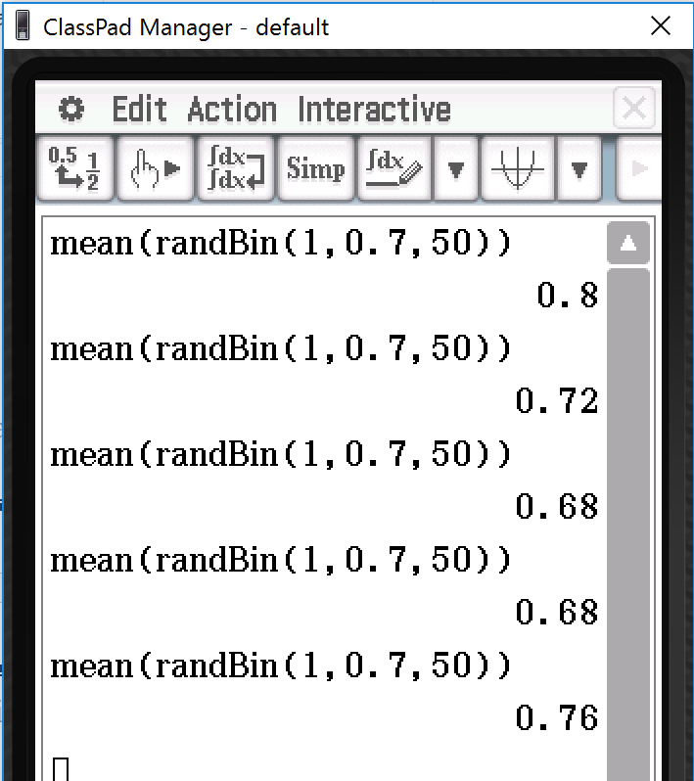

(a) Calculate a 90% confidence interval for the first sample.

(b) Hence comment on the position of *p* in this confidence interval.

(c) Repeat part (a) and (b) for the fourth simulation.

**Question Seven: [1, 1, 4 = 6 marks] CA**

(a) If you were to roll an 8 sided dice (numbered 1 to 8) 8 times, how many times would you expect to roll a prime number?

(b) If you were to roll an 8 sided dice 100 times, what percentage of the time would you expect to roll a prime number?

(c) For 95% of samples of 100 rolls each, what is the interval of expected proportions for the number of prime numbers seen?

**SOLUTIONS**

**Calculator Assumed**

**Confidence Intervals and Margins of Error**

Time: 45 minutes

Total Marks: 45

Your Score: / 45



**Question One: [4 marks] CA**

From a sample of 50 female Year 12 students, it is found that 3 students were told by the Principal that their dresses would be inappropriate for the School Ball.

Use this information to estimate the probability that a female Year 12 student will have to buy another dress for the Ball, to within 2 standard deviations.



**Question Two: [3 marks] CA**

In a given sample there is 60% support for an upgrade to an existing intersection. The estimated variance of the sampling distribution is 0.00014.

How many people were surveyed?



Approximately 1714 people.

**Question Three: [2, 2, 2 = 6 marks] CA**

(a) What confidence level is produced by a margin of error of 1.8 in a standard normal variable?

 

(b) What is the margin of error produced by a confidence level of 90% in a standard normal variable?

 

(c) A smaller margin for error implies what about the level of confidence? Explain your answer.

 The confidence level is the area under the curve. The margin of error is half the interval length. So a small margin of error implies a lower level of confidence.

**Question Four: [3, 2, 2 = 7 marks] CA**

A random variable Y has a mean of  and a standard deviation of 2.4.

200 sample trials of Y were recorded and the mean was  .

(a) State the probability distribution for the sampling distribution of  and explain your answer.

 n is sufficiently large and so by the C.L.T we have:



(b) Calculate a 95% confidence interval for 

 

(c) Calculate a 85% confidence interval for 



**Question Five: [4, 3, 3 = 10 marks] CA**

Chi and Cho run an icecream shop called ChiCho and they’re wondering whether they should also sell coffee at their shop.

(a) Chi thinks that the proportion of customers who would also buy coffee is 0.4. Calculate the size of the sample required for Chi to achieve a margin of error 0f 3% in an approximate 95% confidence interval for this proportion.

 

(b) Cho thinks that the proportion of customers who would also buy coffee is 0.5. Calculate the size of the sample required for Cho to achieve a margin of error of 3% in an approximate 95% confidence interval for this proportion.

 

(c) What is the effect on the margin of error if they Cho is correct but they use the sample size from Chi’s estimate?

 

0.1% larger margin of error

**Question Six: [4, 1, 4 = 9 marks] CA**

The probability of occurrence of a given property is 

The simulation of five samples, each of size 50, was conducted, and the mean of each sample is given below.



(a) Calculate a 90% confidence interval for the first sample.

 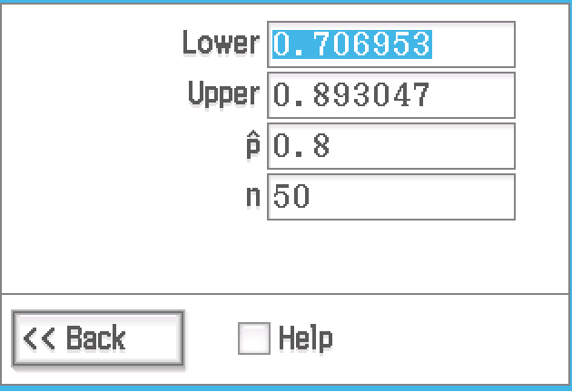

(b) Hence comment on the position of *p* in this confidence interval.

*p* is just within this confidence interval

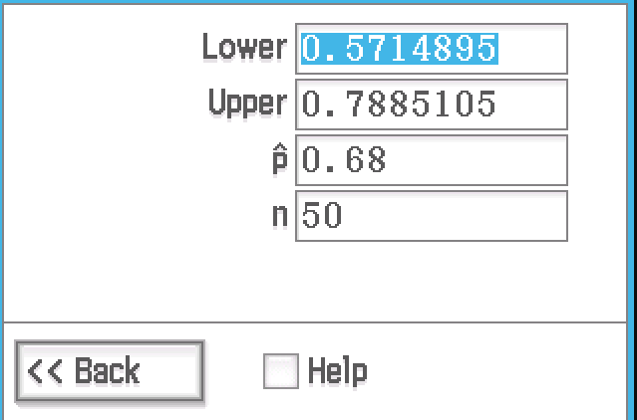(c) Repeat part (a) and (b) for the fourth simulation.

 *p* is well within this confidence interval



**Question Seven: [1, 1, 4 = 6 marks] CA**

(a) If you were to roll an 8 sided dice (numbered 1 to 8) 8 times, how many times would you expect to roll a prime number?

4 times

(b) If you were to roll an 8 sided dice 100 times, what percentage of the time would you expect to roll a prime number?

 50% of the time

(c) For 95% of samples of 100 rolls each, what is the interval of expected proportions for the number of prime numbers seen?



 